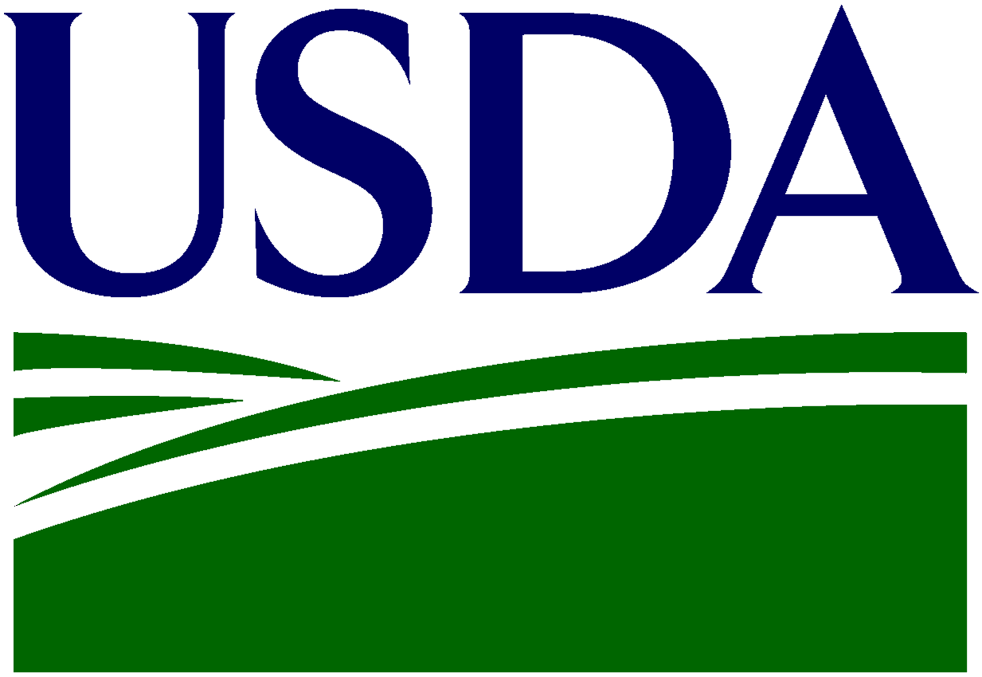
P
U.S. Department of Agriculture
Foreign Agricultural Service

Pet Food Virtual Trade Show Application Form

Return To: cleo.fu@usda.gov

Please fill out completely. Save as Word document only.

Section 1: General Information

Company Name:

Company Logo: (Please enclose separately with application; high resolution files only.)

Product Photos: (Please enclose 2~3 photos; high resolution files only.)

Company Representative Photo: (Please enclose 1 profile photo; high resolution files only.)

Company Description: (Please provide a description of your company to be used on printed materials and for sharing with host country businesses.)

Company Overview:
Contact Name & Title
(Person Most Likely to Join VTS):
Address
(Street, City, State, Zip):
Telephone:
E-Mail:
Website:
Product categories: | (e.g. dry cat food, dry dog good, turtle feed, dog can food, pet treats, etc.)
Year Established:
Number Of Employees:

Section 2: Background Information

Description of Current Products, Services, and Activities:

Description of Current International Activities:

Trade Capacity Volume (Yearly Revenue/Sales):

Section 3: Business Match-Making Profile

Profile of Desired Business Partner: (Please provide information on the sorts of companies with which you are most interested in meeting and be as broad or specific as you prefer.)
Producer:
Processor:
Wholesaler:
Retailer:
Distributor:
Importer/Exporter:
Agency:
Other Institutions:

Section 4: Additional Information

What would you like to achieve by joining this pet food virtual trade show?

How did you find out about this Agribusiness Trade Mission? (check all that apply)

USDA Announcement

State Department of Agriculture Announcement (State: )

Trade or Industry Organization (Name: )

FAS Website

USDA/FAS Social Media (LinkedIn, Twitter)

FAS/GovDelivery Email

Please Note: The information provided by your company for this application is for internal use by the parties that are involved in the preparation of this mission and will not be disclosed to third parties – except for company name, logo, profile, and contact information. If your company is selected to participate, this information will provide the basis for creating your business matches.

Please return to:
cleo.fu@usda.gov

U.S. Department of Agriculture | Foreign Agricultural Service | Connecting U.S. Agriculture to the World

